Mill Hill Hawks SOAR
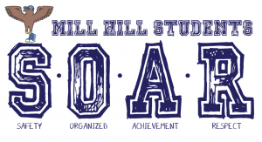
SOAR is our new positive school climate program. Mill Hill students SOAR by showing expected behavior all over the school, and following these values:
S-Safety: I will use self-control to make good choices
O-Organized: I will be prepared and think ahead
A-Achievement: I will always do my best
R-Respect: I will treat others the way I want to be treated

In order to recognize students who show expected behavior and SOAR throughout Mill Hill, students can receive blue SOAR tickets from a teacher or any staff member throughout the school. Be on the lookout for one of these blue tickets to make it home in your child’s backpack! | 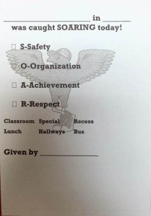
When you visit Mill Hill, you will see new posters throughout the hallways that serve as reminders of SOARing across different areas like the classroom, hallways, lunchroom and playground. | 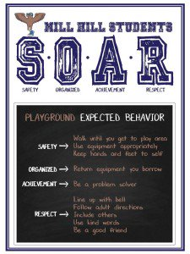
Every room at Mill Hill now has a box full of calming tools for all students to use. To promote problem solving and coping skills, boxes contain tools such as fidgets, stress balls, and visuals that students of all ages can use
Mill Hill students again celebrated Random Acts of Kindness month by filling the hallways with their own acts of kindness | 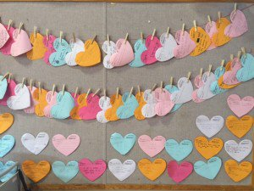
Mill Hill classes are now earning our Shining Star award. Each week, the recess and lunch staff nominate classes who have SOARed during those periods of the day. Classes are announced each Monday and receive a certificate and get to display the Shining Star Trophy for the week. | 